ID WEBSITE USER EXPERIENCE

- LANDING PAGE
  - Size needs to be smaller to fit cellphones screens
- Main site
  - Add Tabs
    - Studio Services
    - Gallery
    - Contact

  - About ID RCRDS - Should just read ID RCRDS
    - Subtitle - IDENTITY // IDEAS // IDEALS

  - The Black Bar should be a thumbnail slide show
  - OUR MISSION - Change to - MISSION
    - At ID RCRDS we are dedicated to expanding the world’s perception of West African music by amplifying artists whose creativity defies boundaries. Through unwavering support, creative freedom, and a commitment to artistic excellence, we strive to cultivate a vibrant community of performers, singer-songwriters, and producers whose voices deserve to be heard on the world stage.
    - IDENTITY
      - defines who an artist is at their core.
    - IDEAS
      - drive what they create and explore.
    - IDEALS
      - represent why they pursue their sound and the values behind it.

  - OUR ARTISTS - Change to ARTISTS
    - Blake Bonsu
    - Media Links - IG, Spotify, Apple Music
    - Bio
      - Blake Bonsu is a Ghanaian-born, UK-raised singer and songwriter whose music blends soulful R&B, neo-soul warmth, and subtle Afro-fusion influences. His sound is defined by smooth vocals, intimate lyricism, and minimalist production that lets emotion take center stage.
Growing up between Ghana and the UK shaped Blake’s unique musical identity. In Britain, he absorbed the storytelling of contemporary R&B and the richness of soul, while his Ghanaian roots grounded his artistry in authenticity and cultural depth. Now based in Ghana, he channels both worlds into a sound that feels global yet deeply personal.
Blake’s music often explores themes of identity, love, growth, and belonging — the quiet complexities of a life lived across continents. His reflective style and emotional honesty have become hallmarks of his work, offering listeners a sense of calm, clarity, and connection.
With each release, Blake Bonsu continues to carve out a thoughtful, resonant space in modern R&B, positioning himself as a refreshing voice bridging the Ghanaian and UK music landscapes.
- KingMidnight
- Media Links - ID, Spotify, Apple Music
- Bio
  - KingMidnight is the melodic alchemist and sound-sculptor behind Midnight Suns, a visionary West African artist whose voice carries both vulnerability and power. As the duo’s primary vocalist, producer, and creative architect, KingMidnight brings depth, mood, and texture to every track—shaping their sonic identity with haunting melodies, layered harmonies, and bold, genre-bending production.
His sound floats between worlds—where R&B meets ambient soul, where electronic pulses merge with ancestral echoes. Whether he's delivering ethereal hooks, crafting atmospheric backdrops, or experimenting with unexpected sonic choices, KingMidnight is constantly pushing boundaries, chasing feeling over formula.
Driven by intuition and innovation, his work reflects an artist unafraid to be fluid: blending the futuristic with the familiar, the sacred with the synthetic. In collaboration with Wes (Wesley Rhymes), he co-pilots Midnight Suns as a platform not just for music, but for movement—a reimagining of what it means to be an African artist in a global soundscape.
KingMidnight is more than a singer or producer—he's a vibe engineer, channeling emotion into sound and crafting immersive experiences that linger long after the last note
- JPG
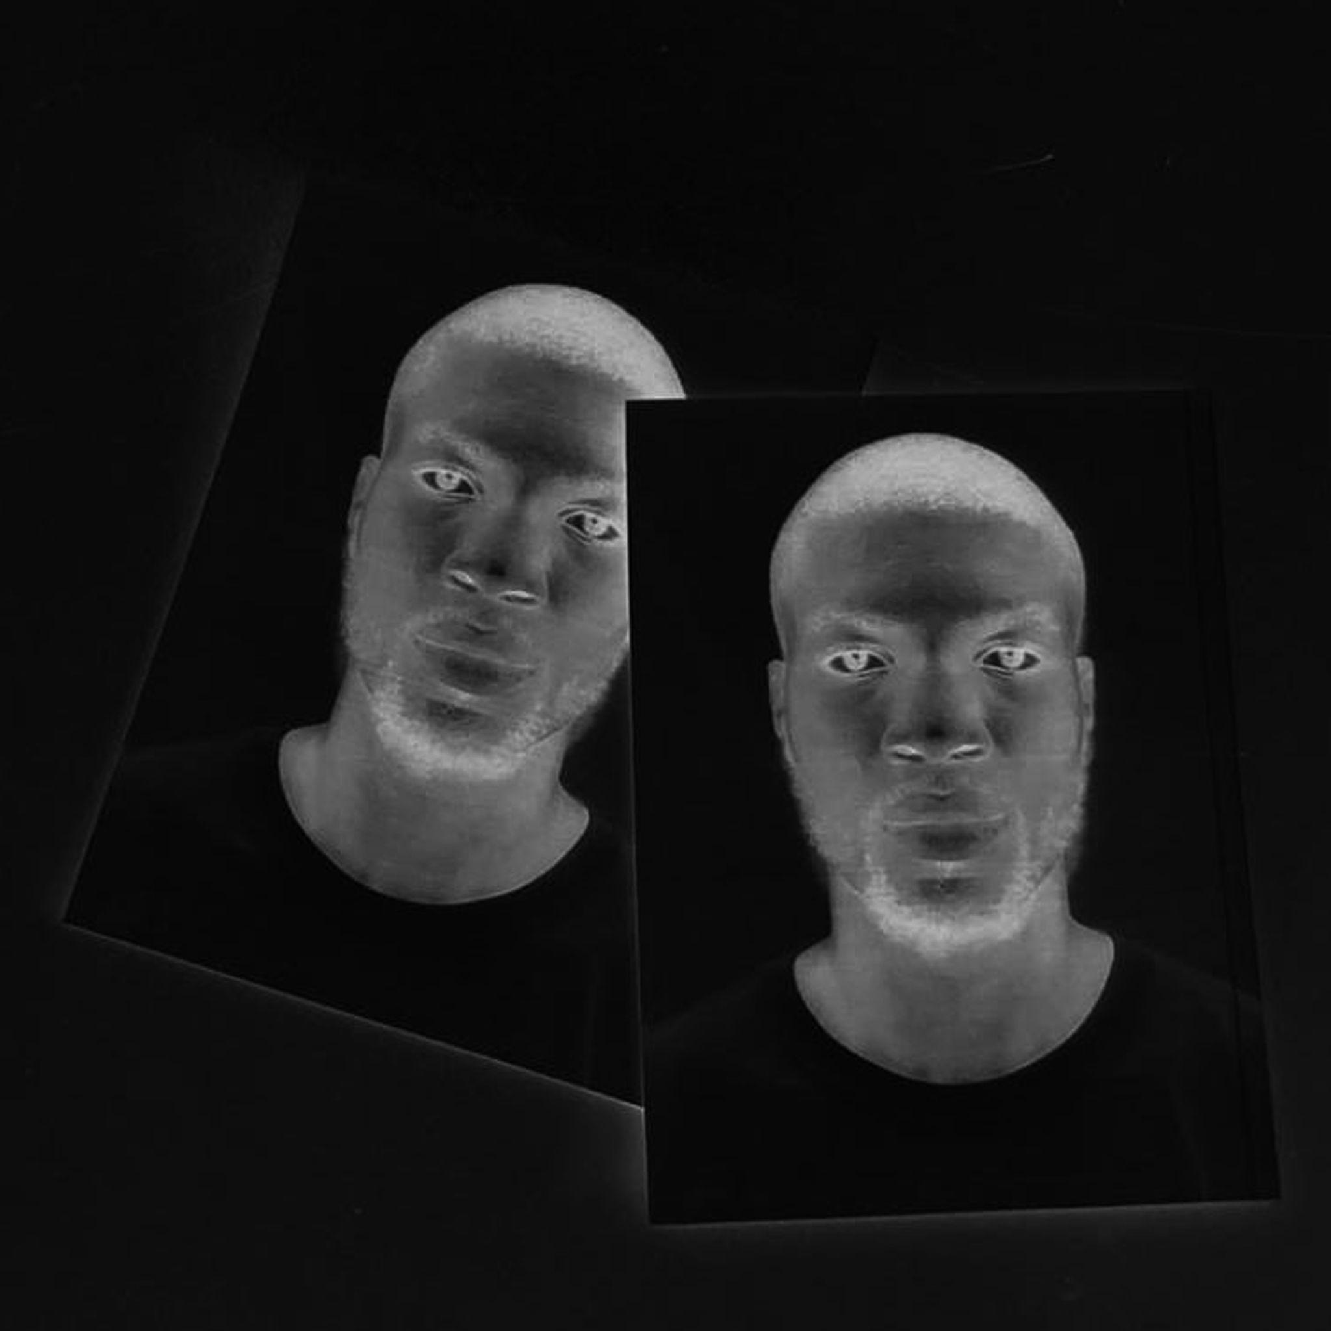
- Midnight Suns
- Media Links - IG, Spotify, Apple Music
- Bio
  - Midnight Suns is a boundary-blurring musical duo of West African origin, formed by longtime collaborators Wes (Wesley Rhymes) and KingMidnight. United by a deep cultural bond and an insatiable hunger to push sound forward, they create genre-defying music that experiments boldly, blends effortlessly, and innovates fearlessly.
Rooted in heritage but unbound by tradition, Midnight Suns crafts immersive sonic landscapes that fuse soul-stirring vocals, textured production, and rhythms that pulse with global influence. Their sound bends categories—think alt-R&B meets electronic grit, poetic rap layered over hypnotic beats, and raw emotion delivered through rich, melodic storytelling.
From the duality and vulnerability of “Two Parts,” to the high-voltage energy of “Dynamite,” to the atmospheric introspection of “W2M,” each track feels like a new chapter in a larger story: one of identity, evolution, and creative freedom.
More than just artists, Wes and KingMidnight are sonic architects—building bridges between continents, genres, and generations. Midnight Suns isn’t just music. It’s movement, mood, and message.
- JPG
  - 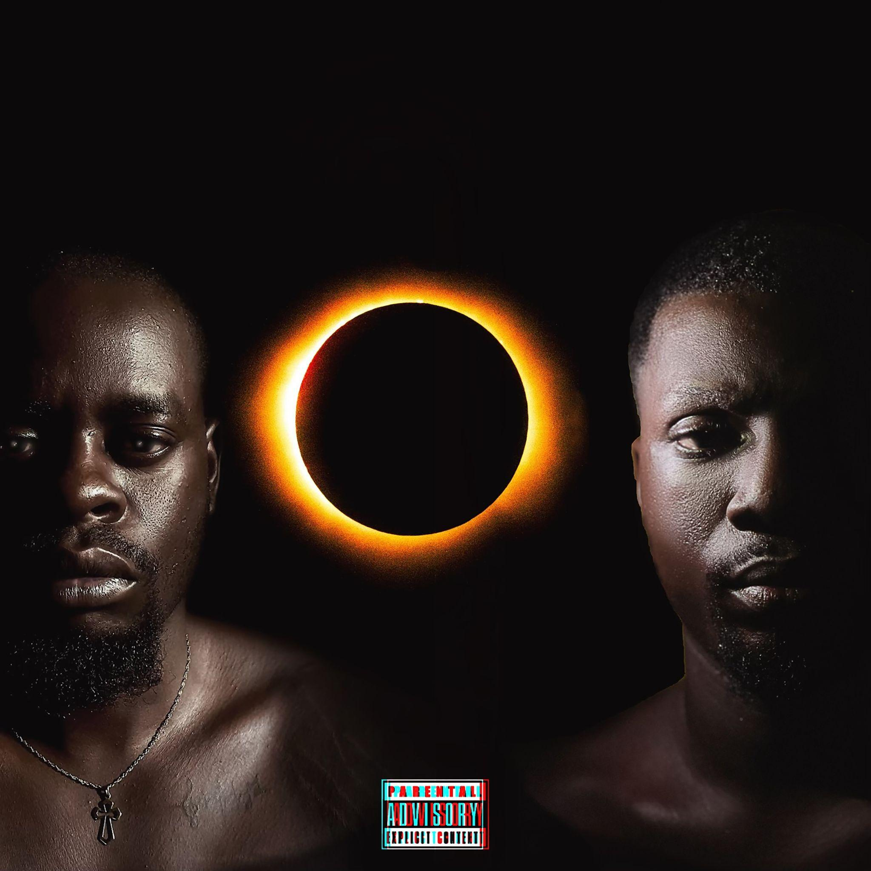

- ABOUT TAB
  - ID RCRDS — built on the pillars of IDentity, IDeas, and IDeals — is a pioneering record label based in Ghana, West Africa. Founded just over two years ago as a subsidiary of ID Entertainment, the label was established with a clear mission: to discover, nurture, and showcase the extraordinary depth of Ghana’s musical talent.
We champion artists who dare to defy genre conventions while honoring the vast diversity and creative power of music. Our focus extends beyond West Africa's traditional commercial sound, empowering musicians who explore R&B, Soul, Alternative, EDM, Rock ’n’ Roll, and other globally influenced genres. Through this, we aim to broaden the world’s understanding of what Ghanaian and West African music can be — expansive, boundless, and shaped by shared global culture.
Since our inception (not the movie), ID RCRDS has grown its roster to include a number of gifted Ghanaian artists — performers, singer-songwriters, and producers — each bringing unique perspectives and innovative soundscapes. Our dedication to creative freedom and artistic expression has allowed us to cultivate a vibrant, supportive community that celebrates both individuality and excellence.
At ID RCRDS, we believe in amplifying the authentic voices of Ghanaian artists and building pathways that propel them onto the global stage. We are committed to redefining the narrative surrounding West African music by showcasing its innovation, diversity, and limitless potential.
- SERVICES TAB

Studio Recording Services
Welcome to ID RCRDS, where artists come to create, experiment, and bring their ideas to life.
Our space is built for musicians, vocalists, producers, podcasters, and creatives who want a professional environment with high-quality engineering and a team that truly understands sound.
From recording and mixing to full production and artist development, we’re here to help you shape a sound that reflects your identity.

Recording Packages

Basic – 200 GHC
A clean, crisp vocal session designed to capture your performance with clarity.
- High-quality recording
- Normalization
- 24-hour delivery

Pro – 300 GHC
A polished, artist-ready product with more room for creativity and shaping your tone.
- High-quality recording
- Normalized & mixed to your taste
- Two revision requests included

Pro Plus – Starting at 450 GHC
A full production finish for artists preparing for release.
- Recording, mixing & mastering
- Normalized and enhanced for streaming-ready quality
- Unlimited edit requests within a two-week delivery window

Additional Studio Services
These are popular offerings we also provide:

Instrumental / Beat Production
Custom beats, production from scratch, or enhancement of existing instrumentals.

Songwriting & Vocal Coaching
Support with melody development, lyric refinement, harmonies, and performance guidance.

Full Mixing Services
Standalone mixing for tracks recorded elsewhere — balancing, EQ, spatial design, vocal enhancement, and stylistic shaping.

Mastering Services
Final polish for radio and streaming platforms—loudness optimization, EQ, limiting, stereo enhancement.

Podcast & Voiceover Recording
High-quality spoken-word recording for podcasts, commercials, narrations, and content creators.

Live Instrument Recording
Professional capture of guitars, keys, drums, and other live instruments.

Music Production Consultation
Creative direction, arrangement guidance, sound selection, and pre-production planning.

Artist Development
Branding assistance, project planning, vocal presence coaching, and helping artists shape their signature sound.

Rehearsal & Creative Sessions
Use of the studio for vocal practice, writing sessions, and collaborative brainstorming.

Sample Budget Scenarios
To make everything more concrete, here are two example scenarios for artists using these services at ID RCRDS, based on current African studio standards:

Scenario A: Emerging Artist
- 3-hour recording session (vocals): ~ 600 GHC
- 1 hour of instrumental production: ~ 300 GHC
- Mixing + mastering (one song): ~ 1,000 GHC
Estimated Total: ~ 1,900 GHC

Scenario B: Full Single Release
- Recording (4 hours): ~ 800 GHC
- Pre-production consultation (2 hours): ~ 600 GHC
- Full production / beat creation (2 hours): ~ 600–1,000 GHC
- Mixing: ~ 800–1,200 GHC
- Mastering: ~ 300–500 GHC
Estimated Total: ~ 3,200–4,100 GHC

Booking Information
All studio bookings require a 3-hour minimum, giving you enough time to settle in and create without pressure.
For custom or bundled services (e.g., record + mix + master + coaching), simply reach out — we’ll tailor a package specifically for your creative needs and budget.
A deposit is required to secure studio time, and full cost breakdowns are provided upfront, ensuring clarity every step of the way.

Let’s Build Your Sound
Every artist works differently. If you have a special idea, a unique request, or a vision you want to explore, we’re here for it.
At ID RCRDS, we don’t just record—we collaborate, create, and help you bring your sound to life.

